$109,000.00
SCHREINER – ELLIOTT
504 12TH ST. WEST, MOBRIDGE
MOBRIDGE BEL AIRE 1ST ADDN., LOT 1 BLOCK 2
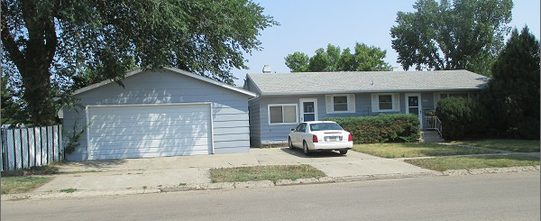
RECORD #4709

LOT SIZE 136’ X 64.9’ GROUND FLOOR 1300 SQ FT
SINGLE FAMILY – 1 STORY BASEMENT 1300 SQ FT
AVERAGE QUALITY & CONDITION 700 SQ FT FIN REC IN BSMT
BUILT IN 1946 3 BEDROOMS ABOVE
2014; ROOF GOOD, CENTRAL AIR 1 BEDROOM BASEMENT
PROPANE HEAT, WINDOWS POOR 1 ½ BATHS
FOUNDATION POOR DET. GARAGE 624 SQ FT
DET. GARAGE; SIDING & ROOF POOR OPEN SLAB PORCH 340 SQ FT
SOLD ON 5/11/21 FOR $109,000
ASSESSED IN 2021 AT $83,290
ASSESSED IN 2012 AT $56,480 RECORD #4709

