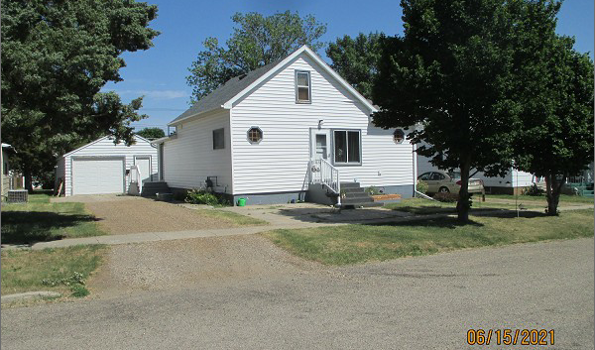
$51,500.00
RABA – LARSON
4719 1ST AVE. SELBY
SELBY OVERHOLSERS ADDN LOT 11 BLOCK 2
RECORD #4549

LOT SIZE 50’ X 140’ GROUND FLOOR 952 SQ FT
SINGLE FAMILY - 1 ½ STORY TOTAL LIVING 1096 SQ FT
AVERAGE QUALITY & CONDITION BASEMENT 952 SQ FT
BUILT IN 1910 900 SQ FT LIVING IN BSMT.
2015; VINYL SIDING, WINDOWS FAIR 2 BEDROOMS – 1 ½ BATHS
CENTRAL AIR – NATURAL GAS DET. GARAGE 600 SQ FT
SOLD ON 2/24/21 FOR $51,500 OPEN SLAB PORCH 160 SQ FT
ASSESSED IN 2021 AT $38,000
SOLD ON 9/126/01 FOR $25,000
ASSESSED IN 2015 AT $21,870 RECORD #4549

