$40,000.00
LEMBURG – RANK
4802 LINCOLN AVE. SELBY
SELBY OVERHOLSERS ADDN LOT 5 BLOCK 2
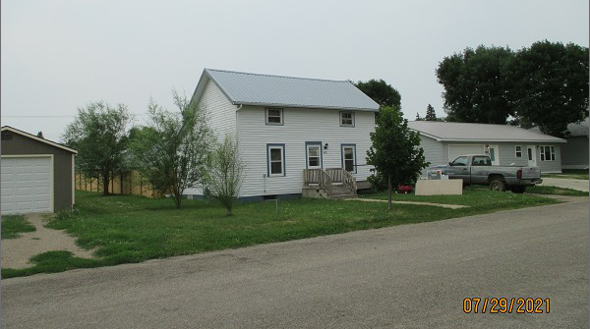
RECORD #4543

LOT SIZE 50’ X 140’ GROUND FLOOR 724 SQ FT
SINGLE FAMILY – 1 ½ STORY TOTAL LIVING AREA 1127 SQ FT
AVERAGE QUALITY & CONDITION 3 BEDROOMS 1 ½ BATHS
BUILT IN 1910 BASEMENT 504 SQ FT
CENTRAL AIR – NATURAL GAS WOOD DECK 392 SQ FT
1999; REMODEL BATHROOM & KITCHEN
2015; METAL ROOF, WOOD LAP SIDING FAIR
ALUM/WOOD WINDOWS
SOLD ON 7/21/2021 FOR $40,000 DETACHED GARAGE 200 SQ FT
ASSESSED IN 2021 $31,230
SOLD ON 11/8/2019 FOR $37,000
ASSESSED IN 2016 AT $29,500 RECORD #4543

