$50,000.00
HOLDER – WALTERS
4106 6TH AVE, SELBY
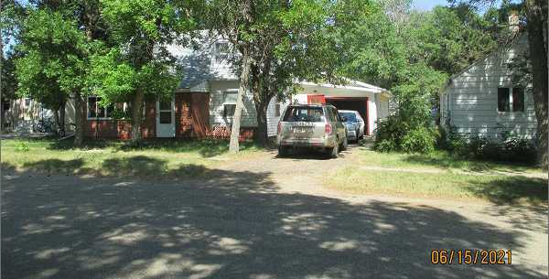
SELBY MILW LAND CO’S 2ND ADDN S 1’6” LOT 4 & ALL OF LOT 5 BLOCK 27
RECORD #4361

LOT SIZE 51.5’ X 140 GROUND FLOOR 768 SQ FT
SINGLE FAMILY – 1 ½ STORY TOTAL LIVING 1152 SQ FT
AVERAGE QUALITY & CONDITION BASEMENT 768 SQ FT
BUILT IN 1948 HALF OF BASMT. FINISHED
2015; ROOF FAIR, WINDOW AIR 3 BEDROOMS
NATURAL GAS, SOME NEWER WINDOWS GARAGE 765 SQ FT
SOLD ON 11/03/2020 FOR $50,000 KNEE WALL PORCH 154 SQ FT
ASSESSED IN 2021 AT $56,550
ASSESSED IN 2016 AT $28,720 RECORD #4361

