$28,000.00
SMITH – SCHICK
5711 1ST AVE. SELBY
SELBY KOSTERS ADDN LOT 1 BLOCK 1
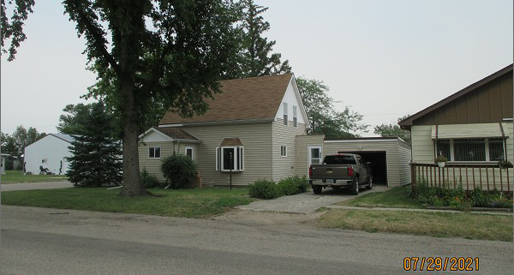
RECORD #4288

LOT SIZE 50’ X 140’ GROUND FLOOR 784 SQ FT
SINGLE FAMILY – 1 ½ STORY TOTAL LIVING 1000 SQ FT
AVERAGE QUALITY – FAIR CONDITION BASEMENT 624 SQ FT
BUILT IN 1899 3 BEDROOMS 1 BATH
2015; BAY WINDOWS, VINYL SIDING PROPANE – CENTRAL AIR
ALUM. WINDOWS, CENTRAL AIR ATT. GARAGE 420 SQ FT
NATURAL GAS, 3 SEASON PORCH KNEE WALL PORCH 64 SQ FT
SOLD ON 6/29/21 FOR $28,000 8’ X 10’ UTILITY SHED
ASSESSED IN 2021 AT $27,570
ASSESSED IN 2013 AT $19,905 RECORD #4288

