$390,000.00
MAYER – SEVERSON
2411 SCHIRBER DR. MOBRIDGE
SCHIRBER’S 2ND ADDITION LOT 6 13-124-80
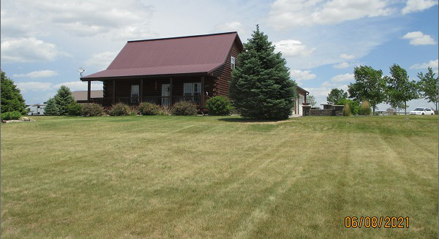
RECORD #7907

LOT SIZE 2.69 ACRES GROUND FLOOR 840 SQ FT
SINGLE FAMILY TOTAL LIVING 1680 SQ FT
2 STORY LOG HOUSE 3 BEDROOMS 2 BATHS
AVERAGE QUALITY ATTACHED GARAGE 840 SQ FT
AVERAGE CONDITION DETACHED GARAGE 1200 SQ FT
BUILT IN 2005 12’ X 26’ ADDITION
NO BASEMENT 8’ X 30’ COVERED DECK
SOLD ON 11/19/2020
ASSESSED IN 2021 AT $362,140
SOLD ON 12/21/09 FOR $126,500
ASSESSED IN 2015 AT $313,100 RECORD #7907

