$55,000.00
F.N. BANK OF GORDON – LEMAIR
STR 18-121-75
S2SE4SE4 18-121-75
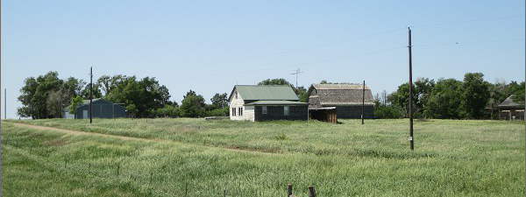
RECORD #7509

LOT SIZE 20 ACRES GROUND FLOOR 1020 SQ FT
SINGLE FAMILY – 1 ½ STORY TOTAL LIVING 1204 SQ FT
AVERAGE QUALITY DET. GARAGE 600 SQ FT
VERY POOR CONDITION POLE BARN 40’ X 60’
BUILT IN 1940 2/STY BARN 60’ X 40’
SOLD ON 12/11/2020 FOR $55,000 BARN 20’ X 30’
ASSESSED IN 2021 AT $28,500
ASSESSED IN 2015 AT $57,120 RECORD #7509

