$257,000.00
BICKEL – PEREZ
1919 KENNEDY DR. MOBRIDGE
MOBRIDGE SHOR ACRES LOTS 98 & 99
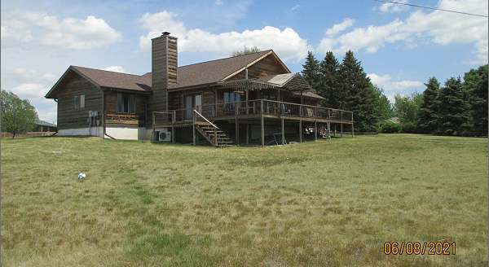
RECORD #6410

LOT SIZE 199’ X 149’ GROUND FLOOR 1877 SQ FT
ONE STORY – SINGLE FAMILY BASEMENT 1752 SQ FT
AVERAGE QUALITY & CONDITION 3 BATHS 2 BEDROOMS
BUILT IN 1986 ATT. GARAGE 588 SQ F
2014; ROUGH HEWN WOOD, CENTRAL AIR
LOTS OF PATCHING & CAULKING WEST & SOUTH
EGRESS ON WEST, WINDOWS GOOD WOOD DECK 725 SQ FT
POURED FOUNDATION SCREENED PORCH 208 SQ FT
SOLD ON 4/28/21 FOR $257,000
ASSESSED IN 2021 AT $256,740
ASSESSED IN 2015 AT $265,180 RECORD #6410

