$320,000.00
TRUAX – JENSEN
1618 KENNEDY MEMORIAL DR. MOBRIDGE
MOBRIDGE SHOR ACRES N. 100’ OF LOT 84
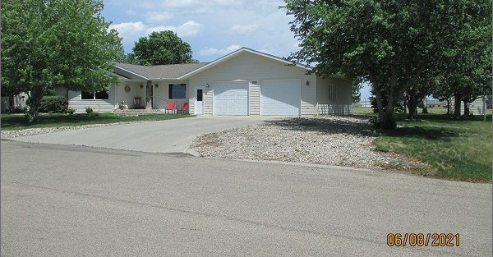
RECORD #6406

LOT SIZE 100’ X 133’ GROUND FLOOR 1796 SQ FT
SINGLE FAMILY – ONE STORY BASEMENT 1080 SQ FT
AVERAGE QUALITY & CONDITION 600 SQ FT FIN. REC. IN BSMT
BUILT IN 1996 3 BEDROOMS ABOVE
2014; SHINGLES GOOD, CEMENT BOARD 1 BEDROOM BELOW
WINDOWS GOOD, POURED FOUNDATION 3 ¼ BATHS
CENTRAL AIR - NATURAL GAS ATT. GARAGE 896 SQ FT
2 EGRESS EAST DET. GARAGE 616 SQ FT
SOLD ON 3/15/21 FOR $320,000
ASSESSED IN 2021 AT $287,440
SOLD ON 8/28/2002 FOR $140,000
ASSESSED IN 2015 AT $283,100 RECORD #6406

