$70,000.00
HULM – KELLER
1103 3RD AVE WEST, MOBRIDGE
MOBRIDGE NWTS 2ND ADDITION LOT 8 BLOCK 17
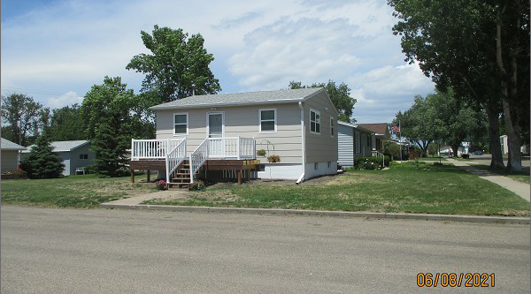
RECORD #6027

LOT SIZE 46’ X 140’ GROUND FLOOR 576 SQ FT
SINGLE FAMILY – ONE STORY FINISHED BSMT 576 SQ FT
AVERAGE QUALITY & CONDITION 1 BEDROOM ABOVE
CENTRAL AIR – NATURAL GAS 3 BEDROOMS BELOW
2007 24’ X 30’ DETACHED GARAGE 1 FULL BATH 2 HALF BATHS
2014; SHINGLES POOR, SIDING GOOD
WINDOWS GOOD
SOLD ON 5/5/21 FOR $70,000 KITCHEN & BATHROOM
ASSESSED IN 2021 AT $71,120 REMODELED IN 2012
SOLD ON 1/15/18 FOR $77,000 UPDATED PLUMBING
ASSESSED IN 2018 AT $69,000 UPDATED ELECTRICAL

