$130,000.00
KNUDSON – TAKEN ALIVE
813 6TH AVE WEST, MOBRIDGE
MOBRIDGE NWTS 1ST ADDN S 28.5’ OF LOT 4 & ALL LOT 5 BLOCK 15
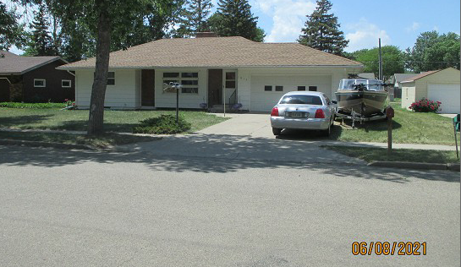
RECORD #6003

LOT SIZE 73.5’ X 140’ GROUND FLOOR 1230 SQ FT
SINGLE FAMILY – 1 STORY 3 BEDROOMS 1 ½ BATHS
AVERAGE QUALITY & CONDITION BASEMENT 1118 SQ FT
BUILT IN 1960 560 SQ FT FIN. REC.
CENTRAL AIR – NATURAL GAS ATTACHED GARAGE 400 SQ FT
2014; ROOF GOOD, FIREPLACE DETACHED GARAGE 320 SQ FT
WINDOWS GOOD, MASONITE SIDING WOOD DECK 56 SQ FT
SOLD ON 4/27/21 FOR $130,000
ASSESSED IN 2021 AT $124,910
ASSESSED IN 2018 AT $121,510 RECORD #6003

