$69,000.00
KNUDSON – COULTER
822 5TH AVE WEST, MOBRIDGE
MOBRIDGE NWTS 1ST ADDN W 85’ OF LOTS 15 & 16 BLOCK 13
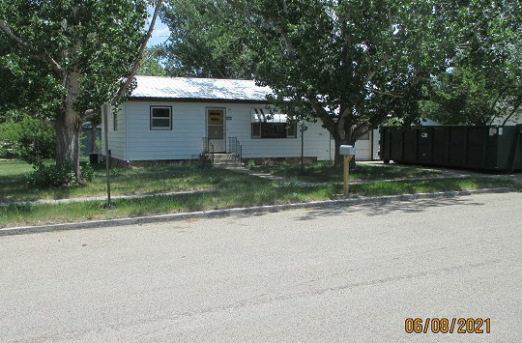
RECORD #5993

LOT SIZE 85’ X 70’ MAIN FLOOR 792 SQ FT
SINGLE FAMLIY – ONE STORY BASEMENT 792 SQ FT
AVERAGE QUALITY & CONDITION BASEMENT 396 SQ FT FIN REC
BUILT IN 1950 2 BEDROOMS – 2 BATHS
CENTRAL AIR – NATURAL GAS ATTACHED GARAGE 336 SQ FT
2015; ROOF POOR, STEEL SIDING SMALL WOOD SHED
ALUMINUM WINDOWS FAIR
2008; BATHROOM REMODEL
SOLD ON 1/21/21 FOR $69,000
ASSESSED IN 2021 AT $61,280
ASSESSED IN 2018 AT $58,530 RECORD #5993

