$40,000.00
AMAN – KDJ PROPERTIES LLC
805 2ND AVE WEST, MOBRIDGE
MOBRIDGE NWTS 1ST ADDN LOTS 5 & 6 BLOCK 11
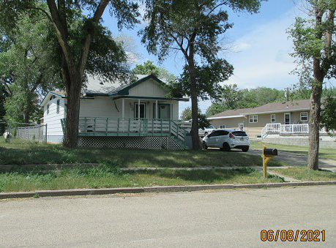
RECORD #5969

LOT SIZE 80’ X 140 MAIN AREA 748 SQ FT
1 ¼ STORY – SINGLE FAMILY TOTAL LIVING 1085 SQ FT
AVERAGE QUALITY & CONDITION 1 BEDROOM MAIN
BUILT IN 1928 2 BEDROOMS UP
CENTRAL AIR – NATURAL GAS 2 BEDROOMS DOWN
2014; BLOCK BSMT, WINDOWS CASEMENT 2 ¾ BATHS
SOME WINDOWS SLIDING SOME ALUMINUM
SOLD ON 12/10/20 FOR $40,000 BSMT 616 SQ FT
ASSESSED IN 2021 AT $58,970 185 SQ FT FIN. REC.
ASSESSED IN 2020 AT $48,810 DET. GARAGE 288 SQ FT

