$128,000.00
PEREZ – KNECHT
902 3RD AVE. WEST, MOBRIDGE
MOBRIDGE NWTS 1ST ADDN LOTS 9 & 10
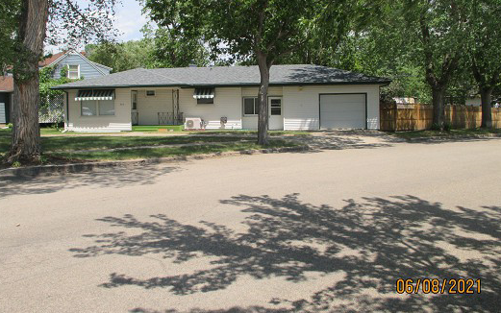
RECORD #5964

LOT SIZE 80’ X 140’ MAIN FLOOR 920 SQ FT
SINGLE FAMILY – ONE STORY BASEMENT 920 SQ FT
AVERAGE QUALITY & CONDITION 2 BEDROOMS ABOVE
CENTRAL AIR – NATURAL GAS 1 BEDROOM BELOW
BUILT IN 1955 1 ¾ BATHS
2014; ROOF POOR, EGRESS NORTH ATT. GARAGE 432 SQ FT
CASEMENT WINDOWS VINYL TRIM NEW OPEN SLAB 299 SQ FT
2016; FINISH BASEMENT $3,000 SWP 198 SQ FT
SOLD ON 4/27/21 FOR $128,000 ROOFED PORCH 40 SQ FT
ASSESSED IN 2021 AT $97,100 SPRINKLER SYSTEM
SOLD ON 7/20/2015 FOR $100,000
ASSESSED IN 2015 AT $72,380 RECORD #5964

