$207,000.00
HATCH – BAUER
902 4TH ST. WEST, MOBRIDGE
MOBRIDGE NWTS 1ST ADDN LOTS 9 & 10 BLOCK 9
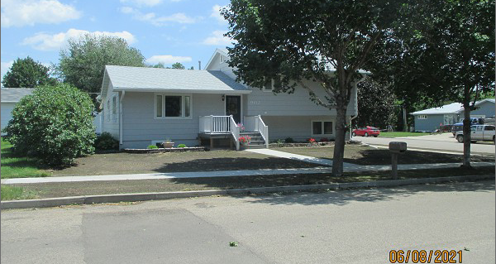
RECORD #5955

LOT SIZE 70’ X 140’ MAIN FLOOR 1,352 SQ FT
SPLIT LEVEL – SINGLE FAMLIY BSMT LIVING 576 SQ FT
AVERAGE QUALITY & CONDITION BSMT REC. 528 SQ FT
BUILT IN 1965 3 BEDROOMS 1 ½ BATHS
2014; BLOCK FOUNDATION DET. GARAGE 864 SQ FT
WINDOWS GOOD, 1 EGRESS OPEN SLAB 440 SQ FT
CENTRAL AIR - NAURAL GAS WOOD DECK 224 SQ FT
SOLD ON 11/20/20 FOR $207,000 TWO 10’X12’ SHEDS
ASSESSED IN 2021 AT $175,090
ASSESSED IN 2018 AT $171,800 RECORD #5955

