$75,000.00
CROSHAW – MERKEL
410 1ST AVE EAST, MOBRIDGE
MOBRIDGE MILWAUKEE LAND CO’S 1ST ADDN LOT 9 BLOCK 20
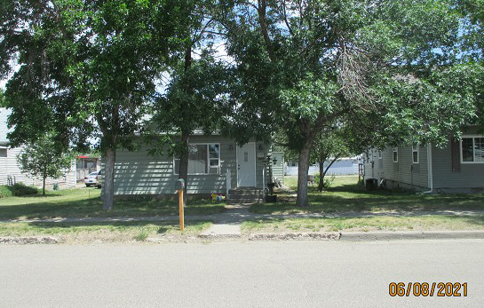
RECORD #5796

LOT SIZE 50’ X 140’ GROUND FLOOR 1434 SQ FT
SINGLE FAMILY TOTAL AREA 1819 SQ FT
ONE STORY WITH ATTIC 2 BEDROOMS 2 BATHS
AVERAGE QUALITY & CONDITION ATTACHED GARAGE 488 SQ FT
BUILT IN EARLY 1900’S ROOFED PORCH 104 SQ FT
2014; FAIRLY NEW SIDING WALLED PORCH 120 SQ FT
FOUNDATION CRACING, NATURAL GAS
BLOCK WINDOWS BASEMENT
SOLD ON 5/13/21 FOR $75,000
ASSESSED IN 2021 AT $34,700
SOLD ON 8/26/16 FOR $45,000 RECORD #5796
ASSESSED IN 2015 AT $34,700

