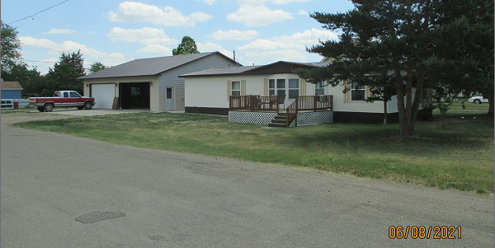
$110,000.00
LILLY- DOUVILLE
526 2ND AVE EAST, MOBRIDGE
MOBRIDGE GRAND CROSSING ADDN N 74’ OF W 150’ OF LOT 11 BLOCK 61
RECORD #5494

LOT SIZE 74’ X 140’ MAIN AREA 1320 SQ FT
MANUFACTURED HOME 3 BEDROOMS 1 ½ BATHS
BUILT IN 1986 42’ X 44’ POLE BUILT IN 2013
24’ X 54’ MEDALLION 16’ X 24’ SHED
NATURAL GAS – CENTRAL AIR WOOD DECK 10’ X 12’
2014; HARDBOARD SIDING
CASEMENT/METAL WINDOWS FAIR
ASPHALT SHINGLES
2011; INTERIOR REMODEL, PLUMBING, FLOOR
SOLD ON 5/28/21 FOR $110,000
ASSESSED IN 2021 AT $45,300
SOLD ON 4/8/13 FOR $16,000 RECORD #5494

