$167,500.00
BROWN – BARTON
721 1ST AVE EAST, MOBRIDGE
MOBRIDGE GRAND CROSSING ADDN LOT 1 BLOCK 59
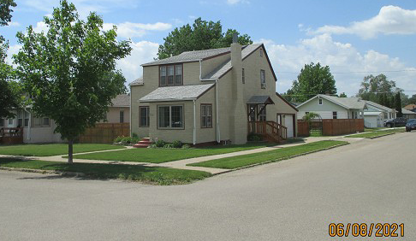
RECORD #5449

LOT SIZE 50’ X 142’ TOTAL LIVING AREA 1224 SQ FT
SINGLE FAMILY – 1 ½ STORY 1ST FLOOR AREA 816 SQ FT
AVERAGE QUALITY & CONDITION 3 BEDROOMS 1 ¾ BATHS
BUILT IN 1920 BASEMENT 816 SQ FT
FORCED AIR & HEATING 400 SQ FT FIN. REC. IN BSMT
2014; STUCCO GOOD, NEWER WINDOWS SOLID WALL PORCH 96 SQ T
ROOF GOOD NEWER BASEMENT WINDOWS ATTACHED GARAGE 816 SQ FT
2006; WOOD FENCE 13’ x 6’
SOLD ON 3/15/2021 FOR $167,500
ASSESSED IN 2021 AT $104,970
SOLD ON 6/8/2016 FOR $130,000 RECORD #5449
ASSESSED IN 2016 AT $83,400

