$10,000.00
STILLE – SHIPLEY
6401 ST. PAUL ST. JAVA
JAVA MILW LAND CO’S 2ND ADDN LOTS 1 & 2 BLOCK 14
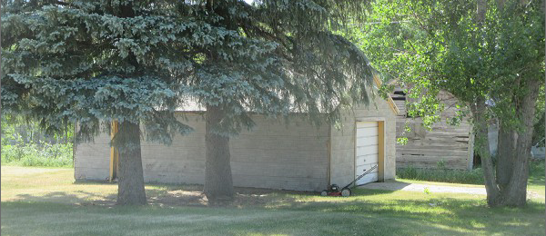
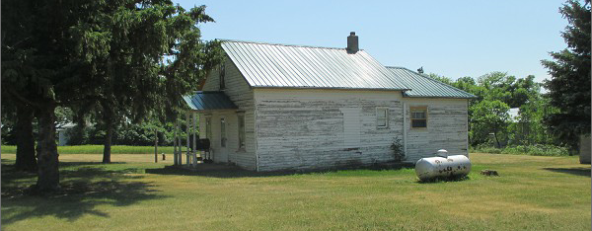
RECORD #4080

LOT SIZE 100’ X 140’ TOTAL LIVING 738 SQ FT
SINGLE FAMILY – ONE STORY 1 BEDROOM 1 BATH
WORN CONDITION BASEMENT 528 SQ FT
AVERAGE QUALITY DETACHED GARAGE 600 SQ FT
BUILT IN 1900 + -
SOLD ON 12/14/21 FOR $10,000
ASSESSED IN 2021 AT $4,725
SOLD ON 4/2/2008 FOR $2,100 RECORD #4080

