$405,000.00
OUTRIM – ANDREE
67 RIVERVIEW DR. NEW EVARTS
LOT 9 IN NEW EVARTS SUBD IN SW4 & W2SE4 29-123-78
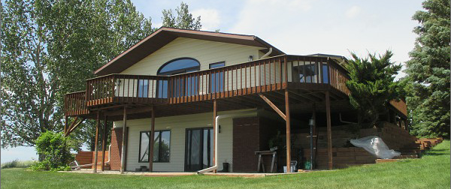
RECORD #2412

LOT SIZE ES1.32 ACRES FIRST FLOOR AREA 1680 SQ FT
SINGLE FAMILY WALKOUT BASEMENT 1680 SQ FT
AVERAGE QUALITY DETACHED GARAGE 1430 SQ FT
AVERAGE CONDITION 3 BEDROOMS – 3 ½ BATHS
CENTRAL AIR 741 SQ FT WOOD DECK
BUILT IN 1994 80 SQ FT KNEE WALL PORCH
SOLD ON 3/10/21 FOR $405,000 CUSTOM CHERRYWOOD CABINETS
ASSESSED IN 2021 AT $360,590
SOLD ON 11/5/2014 FOR $325,000
ASSESSED IN 2014 AT $220,890 RECORD #2412

