$310,000.00
WERNER – SCHROEDER
123 RIVERVIEW DR. NEW EVARTS
LOT 25 IN REPLAT OF NW4 29-123-78
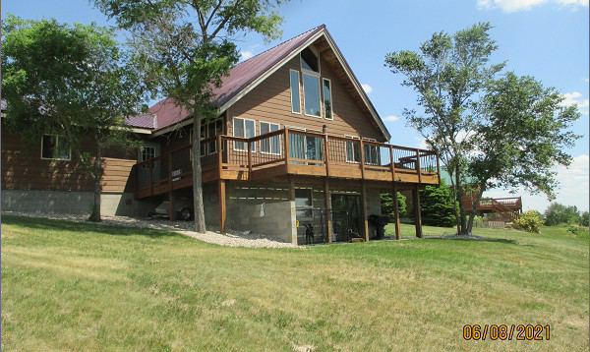
RECORD #2392

LOT SIZE 100’ X 200’ GROUND FLOOR 1120 SQ FT
SINGLE FAMILY – 1 ½ STORY TOTAL AREA 1456 SQ FT
AVERAGE QUALITY & CONDITION BASEMENT 1120 SQ FT
BUILT IN 1980 840 SQ FT LIVING IN BSMT
CENTRAL AIR – PROPANE ATT. GARAGE 600 SQ FT
2013; NEW SIDING & WINDOWS $11,000
2017; TIN ROOF & BATHROOM REMODEL $15,000
SOLD ON 2/25/21 FOR $310,000
ASSESSED IN 2021 AT $185,600 3 BEDROOMS - 2 ½ BATHS
SOLD ON 3/30/16 FOR $160,000
SOLD ON 9/17/09 FOR $120,000 RECORD #2392

