$195,000.00
FN BANK OF GORDON – HAGEMAN
W. 1090’ OF S. 800’ IN SW4 27-121-74
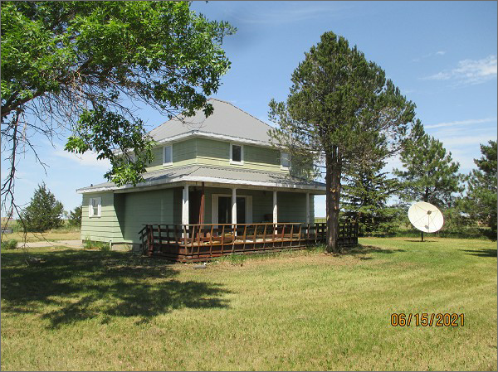
RECORD #129
LOT SIZE 20.02 ACRES, SINGLE FAMILY – 2 STORY, AVERAGE QUALITY- FAIR CONDITION
BUILT IN 1910, GROUND FLOOR 1336 SQ FT, TOTAL LIVING 2488 SQ FT, 3 BEDROOMS
2 BATHS, BASEMENT 1152 SQ FT FINISHED LIVING, ROOFED PORCH 260 SQ FT
WOOD DECK 228 SQ FT,
POLE BARN 40’ X 80’, BARN 60’ X 40’, DET. GARAGE 22’ X 28’, SHED 20’ X 36’

SOLD ON 9/3/2020 FOR $195,000
ASSESSED IN 2021 AT $81,706
ASSESSED IN 2015 AT $164,888

RECORD #129

