$185,000.00
RILEY TRUST – LARSON ET AL
306 12TH ST WEST, MOBRIDGE
MOBRIDGE THOMPSON’S OUTLOTS LOT 2C, 2D & W. 20’ OF W. 55’ OF E. 110’ OF S2 OF LOT 3 (MAPPED AS 3E)
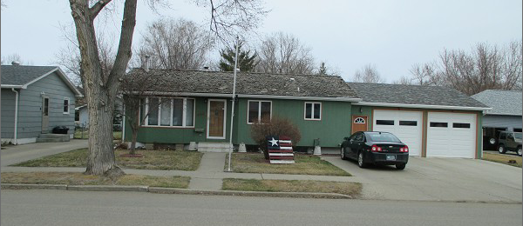
RECORD #650

LOT SIZE 55’ X 244 & 20’ X 122’ MAIN FLOOR 1005 SQ FT
SINGLE FAMILY – ONE STORY BASEMENT 950 SQ FT
AVERAGE CONDITION & QUALITY 500 SQ FT FINISHED BSMT
BUILT IN 1970 3 BEDROOMS ABOVE
2010; 4 SEASON PORCH 15’X15’ 1 BEDROOM BELOW
GARAGE 25’X25’ $50,000 2 FULL BATHS
2015; SHAKES FAIR, VERTICAL HARDBOARD ONE ½ BATH
EGRESS NORTH, CENTRAL AIR, NATURAL GAS
NEWER WINDOWS BASEMENT
ATTACHED GARAGE ROOF GOOD ATT. GARAGE 625 SQ FT
SOLD ON 11/6/2020 FOR $185,000 DET. GARAGE 816 SQ FT
ASSESSED IN 2020 AT $141,460 UTILITY SHED 8’ X 12’
ASSESSED IN 2015 AT $120,830 RECORD #6450

