$6,000.00
DEMARRIAS -BLEYLE
301 3RD AVE EAST, MOBRIDGE
MOBRIDGE MILW. LAND CO’S 1ST ADDN LT 6 BLOCK 18
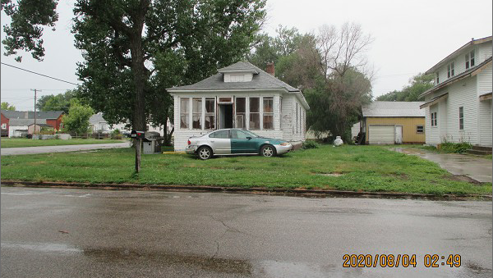
RECORD #5770

LOT SIZE 30’ X 140’ TOTAL LIVING 840 SQ FT
SINGLE FAMILY – 1 STORY 2 BEDROOMS - 1 ½ BATHS
BADLY WORN KNEE WALL PORCH 231 SQ FT
BUILT IN 1920 DETACHED GARAGE 264 SQ FT
2015; ROOF FAIR, SIDING VERY POOR CARPORT 110 SQ FT
3 SEASON PORCH VERY POOR UTILITY SHED 126 SQ FT
WINDOWS POOR, BLOCK BSMT GOOD WOOD DECK 6 SQ FT
SOLD ON 5/22/20 FOR $6,000
ASSESSED IN 2020 AT $18,600
SOLD ON 8/15/11 FOR $17,201
ASSESSED IN 2011 AT $18,120 RECORD #5770

