$125,000.00
OSTER - MANDERNACH
211 9TH AVE EAST, MOBRIDGE
MOBRIDGE DRAEGER’S 1ST ADDN LOT 4 & N2 OF LOT 5 BLOCK 9
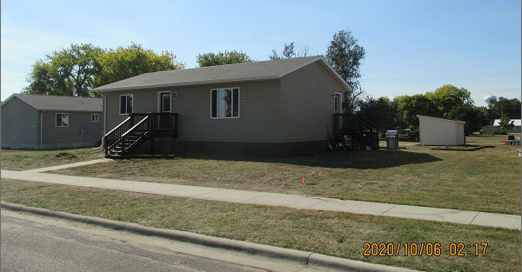
RECORD #4826

LOT SIZE 75’ X 140’ GROUND FLOOR 1008 SQ FT
SINGLE FAMILY – 1 STORY 2 BEDROOMS 1 BATH
AVERAGE QUALITY & CONDITION FINISHED BASMT. 1008 SQ FT
BUILT IN 2010
2014; CENTRAL AIR – NATURAL GAS
2 EGRESS WINDOWS SOUTH 24’ X 42’ GOVERNOR’S HOME
SOLD ON 2/12/21 FOR $125,000
SOLD ON 9/10/20 FOR $48,200 FULL BASEMENT
ASSESSED IN 2020 AT $66,520
SOLD ON 11/03/11 FOR $76,588
ASSESSED IN 2014 A $74,895 RECORD #4826

