$8,500.00
JOB – PAUL
4710 1ST AVE. SELBY
SELBY ORIGINAL LOT 1 BLOCK 1
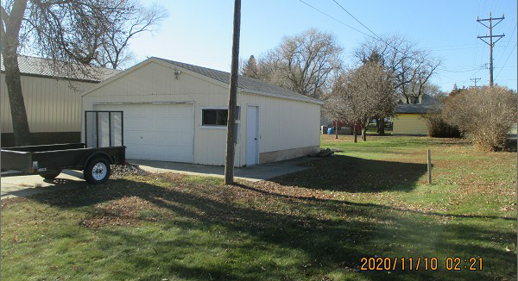
RECORD #4398

LOT SIZE 50’ X 140’
GARAGE ONLY
26’ X 24’
AVERAGE QUALITY & CONDITION
SOLD ON 10/19/20 FOR $8,500
ASSESSED IN 2020 AT $11,360
SOLD ON 12/23/02 FOR $5,000
ASSESSED IN 2014 AT $10,120 RECORD #4398

