$76,500.00
MEAD – DUNBAR
5800 LINCOLN, SELBY
SELBY KOSTERS ADDN LOTS 7 & 8 BLOCK 1
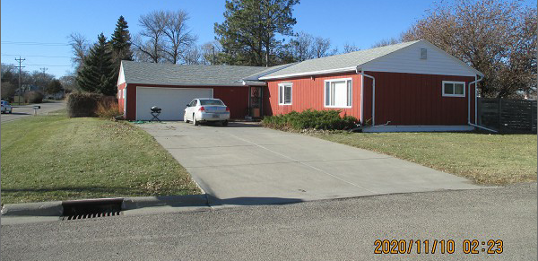
RECORD #4293

LOT SIZE 100’ X 140’ GROUND FLOOR 1556 SQ FT
SINGLE FAMILY – 1 STORY 4 BEDROOMS 1 BATH
AVERAGE QUALITY & CONDITION 8 FIXTURES
BUILT IN 1960 BASEMENT 1556 SQ FT
2015; BOW WINDOW, HARDBOARD 500 SQ FT FIN. REC. IN BSMT.
WINDOWS GOOD, CENTRAL AIR ATTACH. GARAGE 676 SQ FT
ROOF FAIR, LAWN SHED WITH WOOD DECK 240 SQ FT
WRAP AROUND DECK SLAB WOOD GARDEN SHED
SOLD ON 9/21/20 FOR $76,500
ASSESSED IN 2020 AT $120,000
ASSESSED IN 2015 $75,000 RECORD #4293

