$368,500.00
TURNER – HILGEMANN
105 SOUTH RIVERVIEW DR. GLENHAM
NEW EVARTS SECOND SUBDIVISION LOT 1A 29-123-78
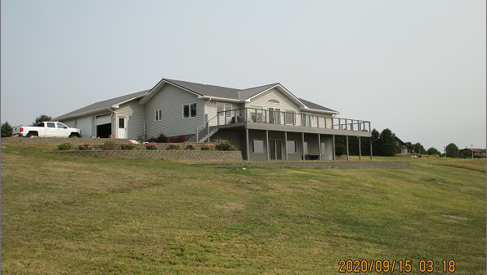
RECORD #7898

LOT SIZE 1.19 ACRES GROUND FLOOR LIVING 1709 SQ FT
SINGLE FAMILY – ONE STORY WALKOUT BASEMENT 1709 SQ FT
AVERAGE QUALITY & CONDITION 2 BEDROOMS UP 3 DOWN
BUILT IN 2005 2 FULL BATHS 2 HALF BATHS
GEO THERMAL HEAT PUMP 3 CAR ATTACHED GARAGE
CENTRAL AIR PROPANE FIREPLACE
LARGE COMPOSITE DECK 558 SQ FT
ROOF OVER PAVER PATIO, WALK OUT FRENCH DOORS
SOLD ON 8/14/20 FOR $368,500
ASSESSED IN 2020 AT $304,130
SOLD ON 8/12/16 FOR $345,000
ASSESSED IN 2015 AT $286,360

