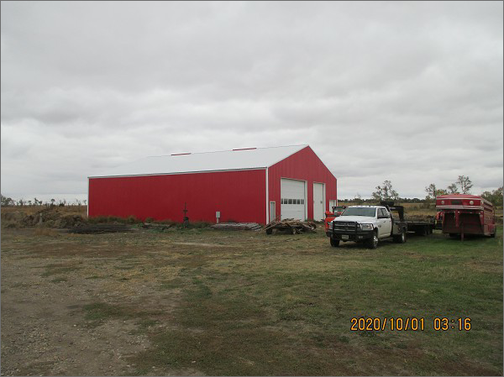
$135,000.00
SUNRISE BANK – MILLER
32112 US HWY 12, BOWDLE
W 1203.84’ OF 836.88’ OF SW4 23-123-74
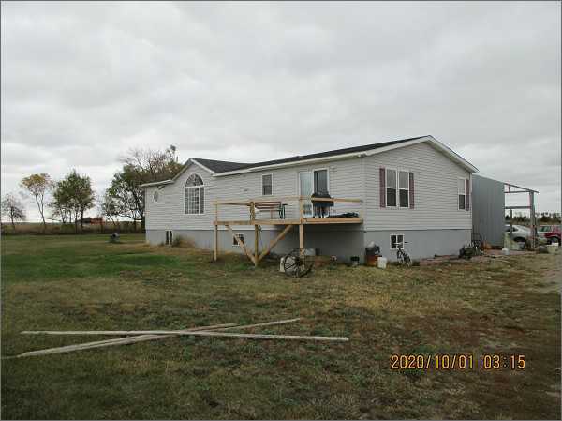
RECORD #7752
23.12 ACRES 2 BEDROOMS ABOVE
1999 MANUFACTURED HOME 2 BEDROOMS BELOW
GROUND FLOOR 1680 SQ FT 2 ½ BATHS
BASEMENT FINISHED 1000 SQ FT
2005; 28’ X 40’ GARAGE $8,000; 30’ X 60’ BARN MOVED IN

30’ X 40’ MACHINE SHED
6/12/19 SHERIFF CERT. 6/15/20 SHERIFF DEED RECORD #7752

