$16,500.00
CURTIS – HESS
1304 2ND ST. EAST, MOBRIDGE
LOTS 4 THRU 9 BLOCK 15 EAST MOBRIDGE ADDN. NE4 29-127-79
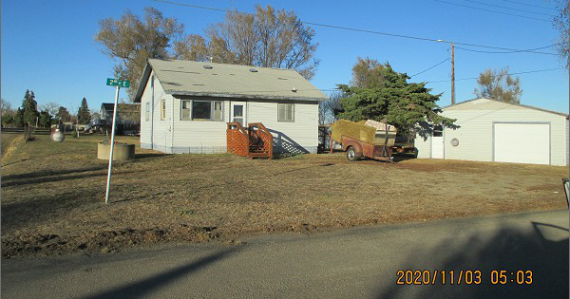
RECORD #7671

LOT SIZE 150’ X 265’ TOTAL LIVING 624 SQ FT
SINGLE FAMILY – 1 STORY 1 BEDROOM 1 BATH
AVERAGE QUALITY & CONDITION DET. GARAGE 780 SQ FT
BUILT IN 1925 WOOD DECK 45 SQ FT
SOLD ON 9/03/20 FOR $16,500
ASSESSED IN 2020 AT $23,325
ASSESSED IN 2013 AT $20,285 RECORD #7671

