$16,825.00
LEMLER – LEMBURG
2911 OVERHOLSER, SELBY
SELBY OVERHOLSER ADDN N. 100’ OF W 150’ IN LOT 2 TRACT 2 OUTLOT A
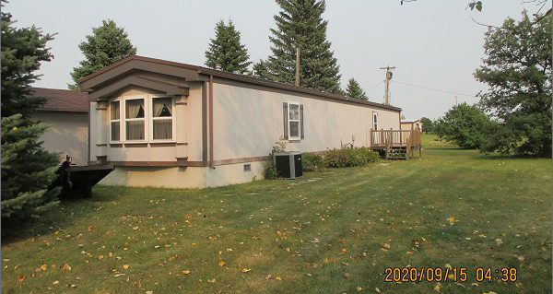
RECORD #7491

LOT SIZE 100’ X 150’ LIVING AREA 1216 SQ FT
MH 1987 16’ X 76’ BONNAVILLA 3 BEDROOMS 2 FULL BATHS
AVERAGE QUALITY & CONDITION WOOD DECK 10’ X 12’
2015; VERTICAL HARDBOARD
CENTRAL AIR – NATURAL GAS
DETACHED GARAGE 24’ X 20’ RECORD #7491
UTILITY SHED 8’ X 10’
SOLD ON 8/21/2020 FOR $16,825
ASSESSED IN 2020 AT $35,000
ASSESSED IN 2015 AT $27,530

