$55,000.00
FIEDLER – OLSON
18 1ST AVE EAST, GLENHAM
GLENHAM ORIGINAL PLAT 6 BLOCK 2
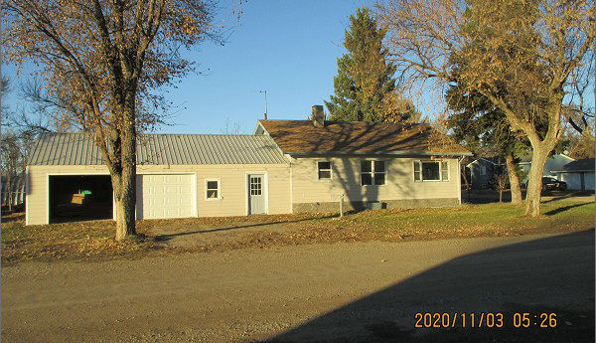
RECORD #6602

LOT SIZE 50’ X 140’ TOTAL LIVING 928 SQ FT
SINGLE FAMILY – 1 STORY BASEMENT 928 SQ FT
FAIR CONDITION & QUALITY ATT. GARAGE 960 SQ FT
BUILT IN 1950 6 FIXTURES 1 ROUGH-IN
2010; ATTACHED GARAGE $6,000 10’ X 10’ UTILITY SHED
SOLD ON 10/20/20 FOR $55,000 2017; NEWER WINDOWS
ASSESED IN 2020 AT $50,350 CEMENT BOARD SIDING
SOLD ON 8/28/08 FOR $25,000
ASSESSED IN 2014 AT $22,860 RECORD #6602

