$120,000.00
AMAN – FAEHNRICH
1304 1ST AVE WEST, MOBRIDGE
MOBRIDGE THOMPSON’S OUTLOTS OT 19E
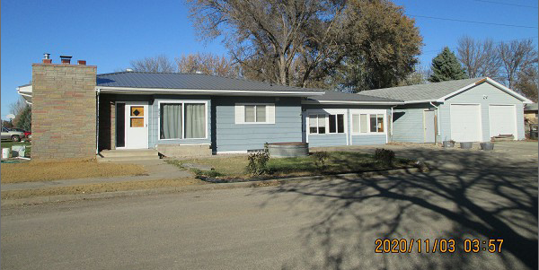
RECORD #6503

LOT SIZE 64’ X 140’ GROUND FLOOR 1610 SQ FT
SINGLE FAMILY – 1 STORY BASEMENT 1082 SQ FT
AVERAGE QUALITY & CONDITION 500 SQ FT FIN REC IN BSMT
BUILT IN 1963 2 BEDROOMS ABOVE
2015; ROOF FAIR, CENTRAL AIR 1 BEDROOM BELOW
ROCK FIREPLACE, NATURAL GAS 2 ½ BATHS
MASONITE WOOD/WOOD POOR DET. GARAGE 1040 SQ FT
GARAGE VINYL POOR, ROOF POOR 3 SEASON PORCH ADDITION
SOLD ON 9/16/20 FOR $120,000
ASSESSED IN 2020 AT $94,300
SOLD ON 3/22/16 FOR $92,500
ASSESSED IN 2015 AT $109,095 RECORD #6503

