$159,000.00
REEVES – HEPPER
1221 1ST AVE WEST, MOBRIDGE
MOBRIDGE THOMPSON’S OUTLOTS LOT 5A, 5B & N 32’ OF LOT 5C
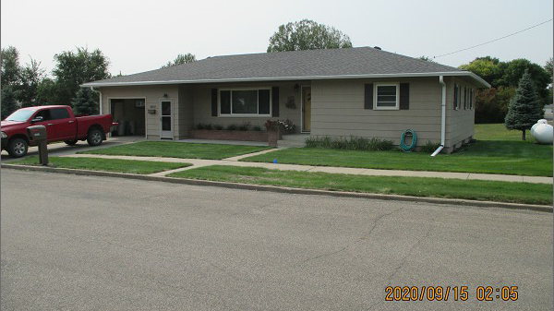
RECORD #6458

LOT SIZE 132’ X 99’ MAIN LIVING AREA 1,316 SQ FT
SINGLE FAMILY – ONE STORY 2 BEDROOMS 1 ½ BATHS
AVERAGE QUALITY & CONDITION BASEMENT 1,164 SQ FT
BUILT IN 1963 800 SQ FT FIN. LIVING IN BSMT.
2015; ROOF GOOD, WOOD SIDING GOOD ATTACHED GARAGE 418 SQ FT
ALUM/ALUM GOOD, CENTRAL AIR ROOFED PORCH 136 SQ FT
SOLD ON 8/20/20 FOR $159,000
ASSESSED IN 2020 AT $130,830
SOLD ON 12/12/05 FOR $74,000
ASSESSED IN 2014 AT $85,760 RECORD #6458

