$130,000.00
UNTERSEHER – MAHAR
112 MAIN ST. MOBRIDGE
MOBRIDGE ORIGINAL PLAT LOTS 11 & 12 BLOCK10
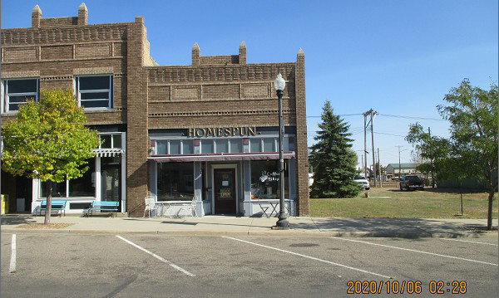
RECORD #’S 6325 & 6326

LOT SIZE 50’ X 140’
60% RETAIL MASONRY BEARING WALLS
40% RETAIL WOOD OR STEEL FRAMED WALLS
BUILT IN 1920’S
AVERAGE QUALITY & CONDITION
1 STORY
TOTAL AREA $3,250 SQ FT
SOLD ON 9/04/20 FOR $130,000
ASSESSED IN 2020 AT $23,835

RECORD #6326 & #6325

