$94,000.00
STICKNEY – SCHAFER
914 8TH ST WEST, MOBRIDGE
MOBRIDGE NWTS CO’S 3RD ADDN E ½ LOTS 7 & 8 BLOCK 32
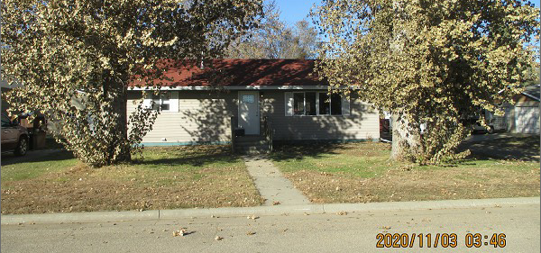
RECORD #6155

LOT SIZE 60’ X 100’ GROUND FLOOR 960 SQ FT
SINGLE FAMILY - 1 STORY BASEMENT 960 SQ FT
AVERAGE QUALITY & CONDITION 2 BEDROOMS 1 ½ BATHS
BUILT IN 1955 NATURAL GAS
2015; REMODEL INTERIOR, PAINT VINYL SIDING
DRYWALL, FLOORING, BATHROOMS
KITCHEN CABINETS, FURNACE, WINDOWS
GUTTERS, $10,000
SOLD ON 10/22/20 FOR $94,000
ASSESSED IN 2020 AT $67,500
SOLD ON 11/21/17 FOR $72,000
ASSESSED IN 2015 AT $43,350 RECORD #6155

