$120,000.00
HIER – PETERSON
901 7TH AVE WEST, MOBRIDGE
MOBRIDGE NWTS CO’S 2ND ADDN S 10’ OF W 80’ OF LOT 5 & ALL LOTS 6 & 7 BLOCK 23
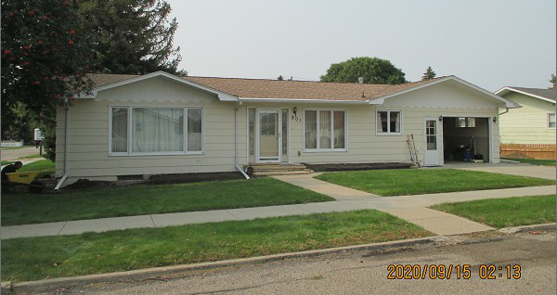
RECORD #6083

LOT SIZE 85’ X 140’ & 10’ X 80’ 1ST FLOOR LIVING 1086 SQ FT
ONE STORY – SINGLE FAMILY 3 BEDROOMS 1 ½ BATHS
AVERAGE QUALITY & CONDITION BASEMENT 1086 SQ FT
BUILT IN 1967 ATTACHED GARAGE 14’ X 24’
2014; ROOF GOOD, MASONITE FAIR ATTACHED GARAGE 20’ X 24’
CENTRAL AIR – NATURAL GAS DETACHED GARAGE 14’ X 12’
3 SEASON PORCH, WINDOWS POOR/FAIR OPEN SLAB PORCH 196 SQ FT
2006; 20’X24’ GARAGE $15,000 OPEN SLAB PORCH 140 SQ FT
SOLD ON 8/08/2020 FOR $120,000
ASSESSED IN 2020 AT $149,830
SOLD ON 9/5/03 FOR $62,500
ASSESSED IN 2014 AT $86,940 RECORD #6083

