$208,000.00
GODKIN – FISCHER
719 12TH ST WEST, MOBRIDGE
MOBRIDGE NWTS CO’S 2ND ADDN LOTS 13-16 BLOCK 20
RECORD #’S 6062 & 6991
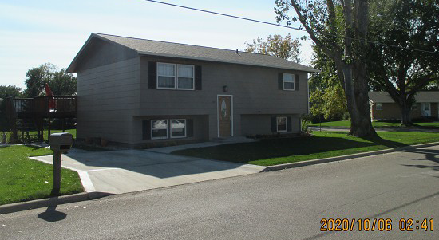

LOT SIZE 184’ X 280’ 1ST FLOOR AREA 840 SQ FT
BI – LEVEL SINGLE FAMILY FINISHED BSMT. 770 SQ FT
AVERAGE QUALITY & CONDITION 2 BEDROOMS ABOVE
BUILT IN 1975 2 BEDROOMS BELOW
2014; SHINGLES FAIR, SPLIT LEVEL 1 ½ BATHS
CENTRAL AIR – NATURAL GAS DET. GARAGE 720 SQ FT
WOOD DECK WITH SLIDING GLASS
SOLD ON 9/04/20 FOR $208,000
ASSESSED IN 2020 AT $115,550
ASSESSED IN 2014 AT $83,980 RECORD #’S 6062 & 6991

