$25,000.00
JACKMAN – GOFF
322 3RD AVE EAST, MOBRIDGE
MOBRIDGE MILW-LAND CO’S 2ND ADDN LOT 12 BLOCK 28
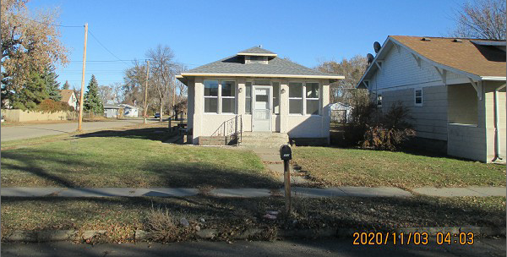
RECORD #5876

LOT SIZE 50’ X 140’ GROUND FLOOR 936 SQ FT
SINGLE FAMILY - 1 STORY BASEMENT 672 SQ FT
FAIR QUALITY & WORN CONDITION 2 BEDROOMS 1 ½ BATHS
BUILT IN 1924 DET. GARAGE 280 SQ FT
2014; STUCCO, SMALL DORMER WEST
3 SEASON PORCH FRONT
CENTRAL AIR, FOUNDATION POOR
SOLD ON 9/10/20 FOR $25,000
ASSESSED IN 2020 AT $19,080
ASSESSED IN 2014 AT $16,250 RECORD #5876

