$40,000.00
PETERS – RABENBERG
306 3RD AVE WEST, MOBRIDGE
MOBRIDGE MILW LAND CO’S 1ST ADDN LOT 8 BLOCK 25
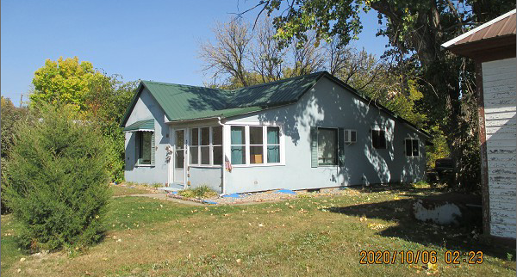
RECORD #5842

LOT SIZE 50’ X 140’ GROUND FLOOR 857 SQ FT
SINGLE FAMILY – 1 STORY 2 BEDROOMS 1 ½ BATHS
AVERAGE QUALITY – WORN CONDITION BASEMENT 670 SQ FT
BUILT IN 1932 KNEE WALL PORCH 108 SQ FT
2009; INT. REMODEL $6,000
2015; METAL ROOF, WINDOW AIR
SLIDING GLASS DOOR EAST
SOME NEW WINDOWS, STUCCO
SOLD ON 9/14/20 FOR $40,000
ASSESSED IN 2020 AT $10,000 RECORD #5842
SOLD ON 6/12/09 FOR $2,000
ASSESSED IN 2015 AT $3,620

