$85,000.00
ALBERS – LASSEN
401 2ND AVE WEST, MOBRIDGE
MOBRIDGE MILW LAND CO’S 1ST ADDN LOT 6 BLOCK 24
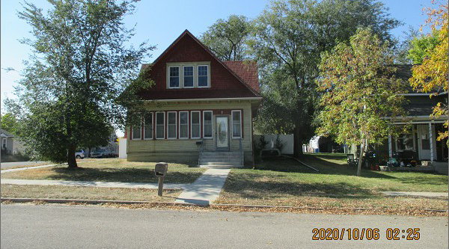
RECORD #5828

LOT SIZE 50’ X 140’ 1ST FLOOR 925 SQ FT
SINGLE FAMILY – 1 ½ STORY TOTAL LIVING 1513 SQ FT
AVERAGE CONDITION & QUALITY 3 BEDROOMS 1 FULL BATH
BUILT IN 1920’S 2 HALF BATHS
2006 REMODEL INT. $16,000 BASEMENT 840 SQ FT
2015; SOME NEWER WINDOWS DET. GARAGE 240 SQ FT
ROOF GOOD, WOOD TRIM POOR
FOUNDATION & SIDING FAIR
SOLD ON 9/14/20 FOR $85,000
ASSESSED IN 2020 AT $64,710
SOLD ON 1/18/20 FOR $64,000
ASSESSED IN 2014 AT $20,950 RECORD #5828

