$9,000.00
BLEYLE – WHILE
310 2ND AVE EAST, MOBRIDGE
MOBRIDGE – MILW LAND CO’S 1ST ADDN LOT 9 BLOCK 18
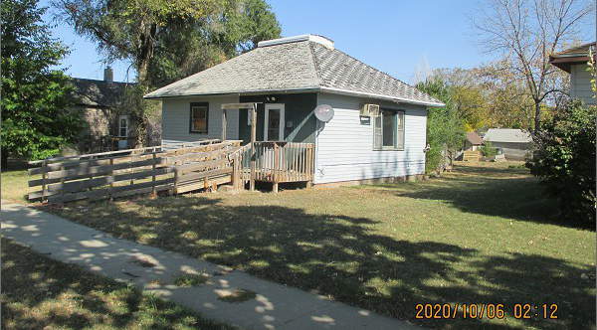
RECORD #5774

LOT SIZE 50’ X 140 TOTAL LIVING 816 SQ FT
SINGLE FAMILY – 1 STORY BASEMENT 240 SQ FT
AVERAGE QUALITY – WORN CONDITION 2 BEDROOMS ABOVE
BUILT IN 1920’S 1 BEDROOM BASMT.
2014; WINDOWS BAD, NATURAL GAS 1 BATH
FOUNDATION BAD, WINDOW AIR
SOLD ON 8/27/20 FOR $9,000
ASSESSED IN 2017 AT $16,220 RECORD #5774

