$3,443.74
HOISINGTON – MILLIKEN INVESTMENTS
206 2ND AVE EAST
MOBRIDGE MILW LAND CO’S 1ST ADDN LOT 8 BLOCK 17
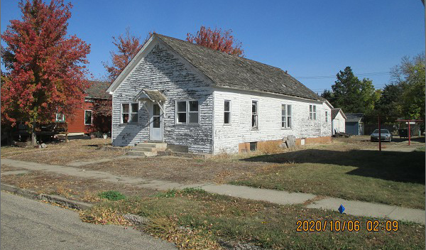
RECORD #5761

LOT SIZE 50’ X 140’ TOTAL LIVING 960 SQ FT
SINGLE FAMILY – ONE STORY 4 BEDROOMS 1 BATH
BADLY WORN CONDITION BASEMENT 960 SQ FT
BUILT IN 19282014; ROOF OLD WOOD BAD 600 SQ FT FIN. REC.
SIDING BAD, WINDOWS BAD DET. GARAGE 308 SQ FT
BSMT WINDOWS BOARDED UP DET. GARAGE 320 SQ FT
SOLD ON 9/09/20 FOR $3,443.74
ASSESSED IN 2020 AT $10,410
SOLD ON 4/23/04 FOR $3,000 RECORD #5761
ASSESSED IN 2013 AT $3,500

