$110,000.00
FIRST DAKOTA ENTERPRISES INC. – BORAH
3RD AVE EAST, MOBRIDGE
MOBRIDGE MILW LAND CO’S 1ST ADDN. LOT 1 & N 38’ OF LOT 2 BLOCK 15
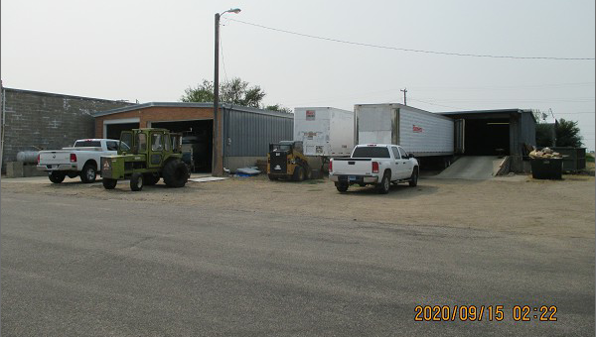
RECORD # 5737

LOT SIZE 88’ X 140’ TOTAL AREA 6,380 SQ FT
100% DISTRIBUTION WAREHOUSE AVERAGE HEIGHT 12’
METAL FRAME & WALLS BUILT IN 1968
AVERAGE CONDITION & QUALITY
SPACE HEATER
SOLD ON 9/08/20 FOR $110,000
ASSESSED IN 2020 AT $79,100
ASSESSED IN 2013 AT $69,205 RECORD #5737

