$131,950.00
HURD – NASH
1015 1ST AVE WEST, MOBRIDGE
MOBRIDGE MAIN PARK S. 12 ½ OF LOT 2 & ALL OF LOT 3 BLOCK 23
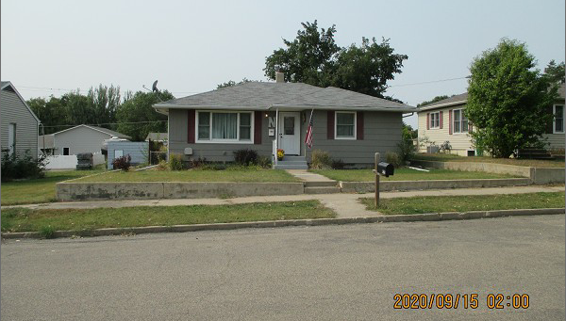
RECORD #5712

LOT SIZE 50’ X 142’ GROUND FLOOR 1252 SQ FT
SINGLE FAMILY – ONE STORY 2 BEDROOMS ABOVE 1 BELOW
AVERAGE QUALITY & CONDITION 1 FULL BATH, ONE ½ BATH
BUILT IN 1963 900 SQ FT FIN. BASEMENT
2014; ROOF GOOD, EGRESS NORTH ATTACHED GARAGE 352 SQ FT
NATURAL GAS – CENTRAL AIR SOLID WALL PORCH 256 SQ FT
SOLD ON 9/04/20 FOR $131,950 OPEN SLAB PORCH 227 SQ FT
ASSESSED IN 2020 AT $122,200 2010; NEW WINDOWS
SOLD ON 6/01/15 FOR $140,000 2010; REMODEL KITCHEN $10,000
SOLD ON 5/12/10 FOR $118,000
ASSESSED IN 2013 $97,940

