$11.500.00
RABENBERG – DR PROPERTIES LLC
722 5TH AVE WEST, MOBRIDGE
MOBRIDGE GRAND CROSSING ADDN LOT 12 BLOCK 54
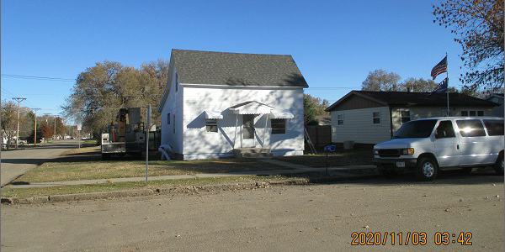
RECORD #5411

LOT SIZE 50’ X 140’ GROUND FLOOR 624 SQ FT
SINGLE FAMILY – 1 ½ STORY TOTAL AREA 792 SQ FT
AVERAGE QUALITY & CONDITION 1 BEDROOM 1 ½ BATHS
BUILT IN 1920 BASEMENT 624 SQ FT
2014; ROOF GOOD, SIDING FAIR DET. GARAGE 672 SQ FT
WINDOW TRIM POOR SLAB PATIO 168 SQ FT
SOLD ON 10/20/20 FOR $11,500
ASSESSED IN 2020 AT $26,490
SOLD ON 7/23/01 FOR $25,000
ASSESSED IN 2014 AT $21,480 RECORD #5411

