$76,000.00
DADY – DADY
521 4TH AVE WEST, MOBRIDGE
MOBRIDGE GRAND CROSSING ADDN LOT 1 BLOCK 37
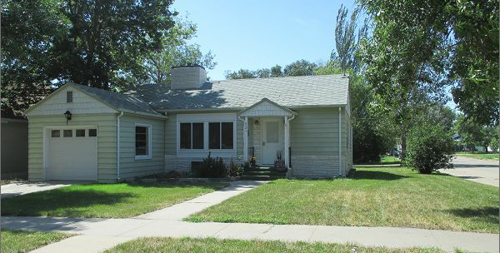
RECORD #5283

LOT SIZE 50’ X 140’ GROUND FLOOR 1090 SQ FT
SINGLE FAMILY – 1 STORY BASEMENT 1090 SQ FT
AVERAGE QUALITY & CONDITION 4 BEDROOMS
BUILT IN 1940’S 2 FULL BATHS, 1 HALF BATH
NATURAL GAS – CENTRAL AIR ATTACHED GARAGE 182 SQ FT
2014; VINYL PLASTIC ROCK TRIM
CASEMENT/VINYL RIM GOOD
SOLD ON 10/01/20 FOR $76,000
ASSESSED IN 2020 AT $48,771
SOLD ON 5/22/12 FOR $54,000
ASSESSED IN 2016 AT $127,841 RECORD #5283

