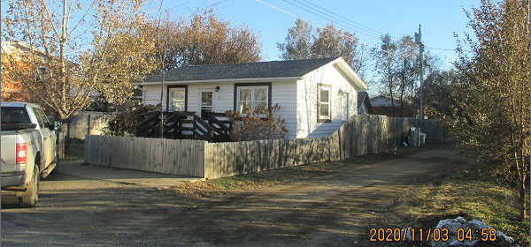
$72,000.00
YUKER – RUSSELL
613 8TH ST EAST, MOBRIDGE
MOBRIDGE FAIRVIEW ADDN W 55’ OF LOTS 1 & 2 & W 55’ OF N 25’
OF LOT 3 BLOCK 13
RECORD #5081

LOT SIZE 55’ X 100’ GROUND FLOOR 560 SQ FT
SINGLE FAMILY – 1 STORY BASEMENT 560 SQ FT
AVERAGE QUALITY & CONDITION 400 SQ FT FIN. REC IN BSMT
BUILT IN 1938 1 BEDROOM 1 BATH
2014; LAP SIDING POOR 8’ X 10’ WOOD DECK
WINDOWS FAIR, BLOCK BSMT 12’ X 18’ DET. GARAGE
CENTRAL AIR – NATURAL GAS
EGRESS SOUTH, NEW CARPET
SOLD ON 10/19/20 FOR $72,000
ASSESSED IN 2020 AT $49,070
SOLD ON 11/17/12 FOR $40,000 RECORD #5081
ASSESSED IN 2014 AT $12,595

