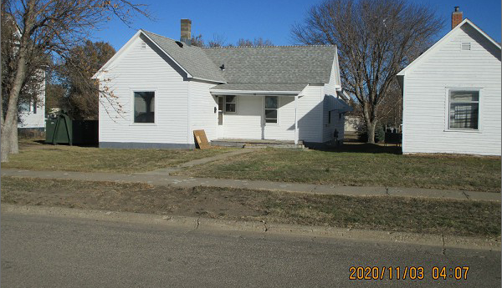
$11,500.00
NORDSTROM – DR PROPERTIES LLC
10 4TH AVE EAST, MOBRIDGE
MOBRIDGE EKLO’S 2ND ADDN LOT 4A
RECORD # 4958

LOT SIZE 46.6’ X 300’ TOTAL LIVING 876 SQ FT
SINGLE FAMILY – 1 STORY 1 BEDROOM 1 BATH
FAIR CONDITION & QUALITY NO BASEMENT
BUILT IN 1917 DET. GARAGE 352 SQ FT
2014; NATURAL GAS, FOUNDATION POOR
OLD SHEDS IN BACK, WINDOW AIR UTILITY SHED 8’ X 10’
SOLD ON 9/29/20 FOR $11,500 OPEN ROOFED PORCH
ASSESSED IN 2020 AT $13,880
ASSESSED IN 2014 AT $21,780 RECORD #4958

