$50,000.00
WILLERT – HUNSTAD
2608 2ND AVE. SELBY
SELBY ORIGINAL LOT 2 & N11’ OF LOT 3 BLOCK 12
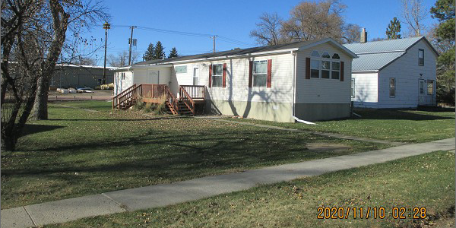
RECORD #4482

LOT SIZE 61’ X 140’ MAIN AREA 1,216 SQ FT
MANUFACTURED HOME 2 FULL BATHS
16’ X 80’ CHAMPION WOOD DECK 10’ X 16’
AVERAGE QUALITY & CONDITION ENTRY 10’ X 16’
BUILT IN 2013 UTILITY SHED 10’ X 8’
2015; ROOF GOOD, VINYL SIDING
ENTRY SOUTH, WOOD DECK
NATURAL GAS – CENTRAL AIR
SOLD ON 9/11/20 FOR $50,000
ASSESSED IN 2020 AT $52,830
SOLD ON 4/29/16 FOR $55,000
ASSESSED IN 2016 AT $65,500
SOLD ON 6/2/14 FOR $70,000
ASSESSED IN 2014 AT $66,950 RECORD #4482

